In this course, we will cover interviewing techniques and walkthroughs of common questions with all of the above in mind. You will first walk through the following:
Go inside the mind of the employer - why is the company hiring for this role?
Identify a business problem - showcase you're interested in solving the root issues in order to prevent further problems.
Explore potential data sources - see how your solution depends on your unique dataset.
Discuss machine learning solutions - get familiar with answering interview questions for this unique field.
Practice answering technical questions - bolster your confidence for interview day by practicing interview techniques.

Go inside the mind of the employer
If a company wants to hire a machine learning engineer (or data analyst or scientist), it’s clear that they are trying to solve a complex problem where traditional algorithmic solutions are hard to apply or simply do not work well enough. They are also extremely motivated to solve that problem (otherwise they wouldn’t be in this business!).

Reflection Exercise
Before the interview, or even before you apply to a job, investigate possible answers to these questions:

Why is the company hiring?
Does it look like they're backfilling (ie: someone left the company or was promoted, so they need to fill in the job)? Or, are they expanding their team (therefore investing more in data science) or even starting their data team for the first time? These answers will help you see how you're needed. If the company is looking for a member of a large team, they likely need you to fill in a specific role and may want you to show expert skill in a specialization. If they're building out their data team, they may be looking for someone who's a fast learner and can help them make decisions - since they may not know what they need from a data team.

How will this company's data team grow?
This will give you insight on longterm opportunities for you. If they're growing rapidly, that may signal you have potential to become a team lead in the future.

Which business problem are they trying to solve?

Identify a Business Problem
Imagine yourself in the role – find out as much as possible about the company and position. Then ask yourself: What is one core problem I need to solve? The answer should excite you, and drive you to find out more about the problem, existing approaches, and recent developments in that domain. Choose a problem that is essential for the company.
For example, as a Machine Learning Engineer at Udacity, your primary responsibility could be to improve student engagement and retention. It is widely known that MOOC completion rates are abysmally low. Why do students drop out of our programs? Do they find our content too hard, or too easy? How can we improve student engagement in the classroom?
Although you may not be able to figure this out, you can think of realistic possibilities. For example, an e-vendor may want to make better recommendations based on search history. A healthcare company may want to better predict health risks. When you are in the interview, connect your past experiences to how you can fix these hypothetical issues.

What else?
Don't forget to ask your interviewers the questions in this exercise, also! Not only do you want to know the answers, asking will showcase your interest and thoughtfulness.

Prepare to Demonstrate these Technical Skills
Here are the essential skills that a Machine Learning Engineer needs, as mentioned in the first video of this lesson. Within each group are topics that you should be familiar with.
Study Tip: Copy and paste this list into a document and save to your computer for easy referral.

Computer Science Fundamentals and Programming
Topics
- Data structures: Lists, stacks, queues, strings, hash maps, vectors, matrices, classes & objects, trees, graphs, etc.
- Algorithms: Recursion, searching, sorting, optimization, dynamic programming, etc.
- Computability and complexity: P vs. NP, NP-complete problems, big-O notation, approximate algorithms, etc.
- Computer architecture: Memory, cache, bandwidth, threads & processes, deadlocks, etc.

Probability and Statistics
Topics
- Basic probability: Conditional probability, Bayes rule, likelihood, independence, etc.
- Probabilistic models: Bayes Nets, Markov Decision Processes, Hidden Markov Models, etc.
- Statistical measures: Mean, median, mode, variance, population parameters vs. sample statistics etc.
- Proximity and error metrics: Cosine similarity, mean-squared error, Manhattan and Euclidean distance, log-loss, etc.
- Distributions and random sampling: Uniform, normal, binomial, Poisson, etc.
- Analysis methods: ANOVA, hypothesis testing, factor analysis, etc.

Data Modeling and Evaluation
Topics
- Data preprocessing: Munging/wrangling, transforming, aggregating, etc.
- Pattern recognition: Correlations, clusters, trends, outliers & anomalies, etc.
- Dimensionality reduction: Eigenvectors, Principal Component Analysis, etc.
- Prediction: Classification, regression, sequence prediction, etc.; suitable error/accuracy metrics.
- Evaluation: Training-testing split, sequential vs. randomized cross-validation, etc.

Applying Machine Learning Algorithms and Libraries
Topics
- Models: Parametric vs. nonparametric, decision tree, nearest neighbor, neural net, support vector machine, ensemble of multiple models, etc.
- Learning procedure: Linear regression, gradient descent, genetic algorithms, bagging, boosting, and other model-specific methods; regularization, hyperparameter tuning, etc.
- Tradeoffs and gotchas: Relative advantages and disadvantages, bias and variance, overfitting and underfitting, vanishing/exploding gradients, missing data, data leakage, etc.

Software Engineering and System Design
Topics
- Software interface: Library calls, REST APIs, data collection endpoints, database queries, etc.
- User interface: Capturing user inputs & application events, displaying results & visualization, etc.
- Scalability: Map-reduce, distributed processing, etc.
- Deployment: Cloud hosting, containers & instances, microservices, etc.
Move on to the final lesson of this course to find lots of sample practice questions for each topic!

Essential Skills Needed by Machine Learning Engineers
Now that you've had a chance to observe a mock interview, let's dig into the specifics of skills you should be ready to demonstrate in an interview.
These skills can be divided into the following groups:
- Computer Science Fundamentals
- Probability and Statistics
- Data Modeling and Evaluation
- Applying Machine Learning Algorithms and Libraries
- Software Engineering and System Design
Within each group are topics that you should be familiar with. In the next few sections, we've provided you some sample questions that you may be asked in an interview.

Computer Science Fundamentals and Programming

Topics:
- Data structures: Lists, stacks, queues, strings, hash maps, vectors, matrices, classes & objects, trees, graphs, etc.
- Algorithms: Recursion, searching, sorting, optimization, dynamic programming, etc.
- Computability and complexity: P vs. NP, NP-complete problems, big-O notation, approximate algorithms, etc.
- Computer architecture: Memory, cache, bandwidth, threads & processes, deadlocks, etc.

Questions:
- How would you check if a linked list has cycles?
- Given two elements in a binary search tree, find their lowest common ancestor.
- Write a function to sort a given stack.
- What is the time complexity of any comparison-based sorting algorithm? Can you prove it?
- How will you find the shortest path from one node to another in a weighted graph? What if some weights are negative?
- Find all palindromic substrings in a given string.
For all such questions, you should be able to:
- Reason about the time and space complexity of your approach (usually in big-O notation).
- Try to aim for the lowest complexity possible.
Extensive practice is the only way to familiarize yourself with the different classes of problems so that you can quickly converge on an efficient solution.
Coding/interview prep platforms like InterviewBit, LeetCode and Pramp are highly beneficial for this purpose.

Probability and Statistics

Probability and Statistics

opics:
- Basic probability: Conditional probability, Bayes rule, likelihood, independence, etc.
- Probabilistic models: Bayes Nets, Markov Decision Processes, Hidden Markov Models, etc.
- Statistical measures: Mean, median, mode, variance, population parameters vs. sample statistics etc.
- Proximity and error metrics: Cosine similarity, mean-squared error, Manhattan and Euclidean distance, log-loss, etc.
- Distributions and random sampling: Uniform, normal, binomial, Poisson, etc.
- Analysis methods: ANOVA, hypothesis testing, factor analysis, etc.

Questions:
- The mean heights of men and women in a population were calculated to be Mand W. What is the mean height of the total population?
- A recent poll revealed that a third of the cars in Italy are Ferraris, and that half of those are red. If you spot a red car approaching from a distance, what is the likelihood that it is a Ferrari?
- You’re trying to find the best place to put in an advertisement banner on your website. You can make the size (thickness) small, medium or large, and choose vertical position top, middle or bottom. At least how many total page visits (n) and ad clicks (m) do you need to say with 95% confidence that one of the designs performs better than all the other possibilities?
- The time period between consecutive eruptions of the Old Faithful geyser in Yellowstone National Park is found to have the following distribution. How would you describe/characterize it? What can you infer from it?
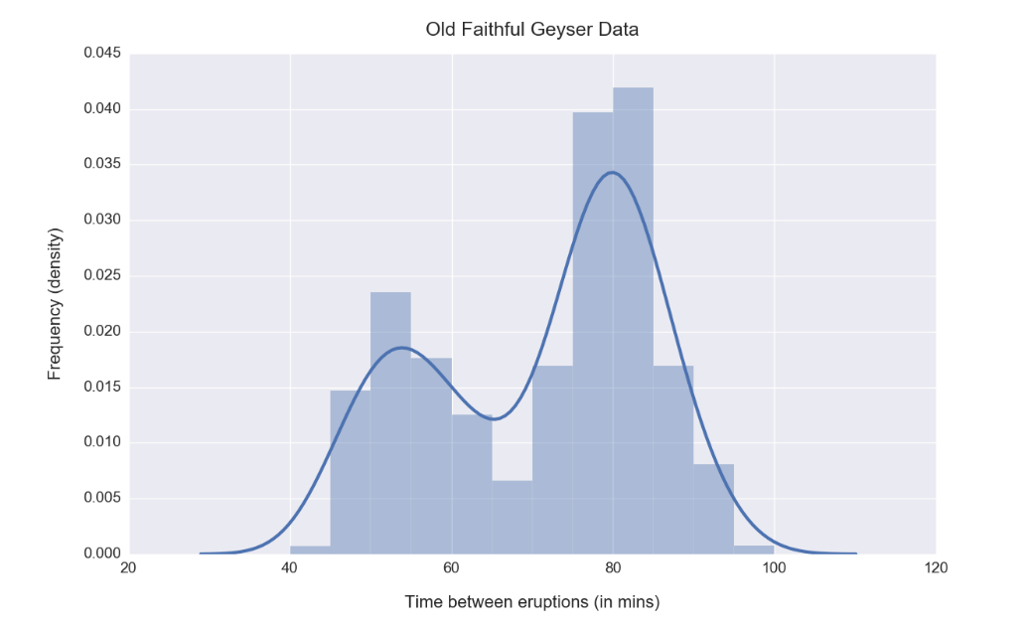
Remember: many machine learning algorithms have a basis in probability and statistics. Conceptual clarity of these fundamentals is extremely important, but at the same time, you must be able to relate abstract formulae with real-world quantities.

Data Modeling and Evaluation

opics:
- Data preprocessing: Munging/wrangling, transforming, aggregating, etc.
- Pattern recognition: Correlations, clusters, trends, outliers & anomalies, etc.
- Dimensionality reduction: Eigenvectors, Principal Component Analysis, etc.
- Prediction: Classification, regression, sequence prediction, etc.; suitable error/accuracy metrics.
- Evaluation: Training-testing split, sequential vs. randomized cross-validation, etc.

Questions:
- A dairy farmer is trying to understand the factors that affect milk production of her cattle. She has been keeping logs of the daily temperature (usually 30-40°C), humidity (60-90%), feed consumption (2000-2500 kgs), and milk produced (500-1000 liters).
  - How would you begin processing the data in order to model it, with the goal of predicting liters of milk produced in a day?
  - What kind of machine learning problem is this?
- Your company is building a facial expression coding system, which needs to take input images from a standard HD 1920x1080 pixel webcam, and continuously tell whether the user is in one of the following states: neutral, happy, sad, angry or afraid. When the user’s face is not visible in the camera frame, it should indicate a special state: none.
  - What class of machine learning problems does this belong to?
  - If each pixel is made up of 3 values (for red, green, blue channels), what is the raw input data complexity (no. of dimensions) for processing each image? Is there a way to reduce the no. of dimensions?
  - How would you encode the output of the system? Explain why.
- Climate data collected over the past century reveals a cyclic pattern of rising and falling temperatures. How would you model this data (a sequence of average annual temperature values) to predict the average temperature over the next 5 years?
- Your job at an online news service is to collect text reports from around the world, and present each story as a single article with content aggregated from different sources. How would you go about designing such a system? What ML techniques would you apply?

Applying Machine Learning Algorithms and Libraries

Topics:
- Models: Parametric vs. nonparametric, decision tree, nearest neighbor, neural net, support vector machine, ensemble of multiple models, etc.
- Learning procedure: Linear regression, gradient descent, genetic algorithms, bagging, boosting, and other model-specific methods; regularization, hyperparameter tuning, etc.
- Tradeoffs and gotchas: Relative advantages and disadvantages, bias and variance, overfitting and underfitting, vanishing/exploding gradients, missing data, data leakage, etc.

Questions:
- You’re trying to classify images of cats and dogs. Plotting the images in some transformed 2-dimensional feature space reveals the following pattern (on the left). In some other space, images of dogs and wolves show a different pattern (on the right).
  - What model would you use to classify cats vs. dogs, and what would you use for dogs vs. wolves? Why?
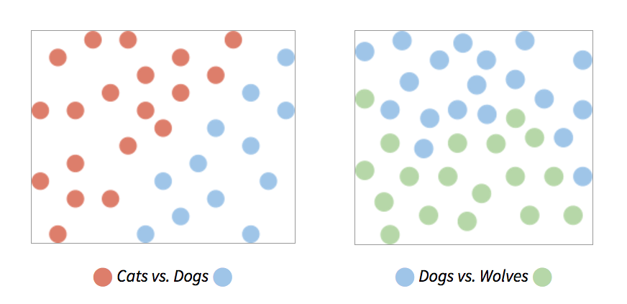
- I’m trying to fit a single hidden layer neural network to a given dataset, and I find that the weights are oscillating a lot over training iterations (varying wildly, often swinging between positive and negative values). What parameter do I need to tune to address this issue?
- When training a support vector machine, what value are you optimizing for?
- Lasso regression uses the L1-norm of coefficients as a penalty term, while ridge regression uses the L2-norm. Which of these regularization methods is more likely to result in sparse solutions, where one or more coefficients are exactly zero?
- When training a 10-layer neural net using backpropagation, I find that the weights for the top 3 layers are not changing at all! The next few layers (4-6) are changing, but very slowly. What’s going on and how do I fix this?
- I’ve found some data about wheat-growing regions in Europe that includes annual rainfall (R, in inches), mean altitude (A, in meters) and wheat output (O, in kgs/km2). A rough analysis and some plots make me believe that output is related to the square of rainfall, and log of altitude: O = β0 + β1 × R2 + β2 × loge(A)
  - Can I fit the coefficients (β) in my model to the data using linear regression?
Machine Learning challenges such as those on Kaggle are a great way to get exposed to different kinds of problems and their nuances. Try to participate in as many as you can, and apply different machine learning models.

Software Engineering and System Design

Topics:
- Software interface: Library calls, REST APIs, data collection endpoints, database queries, etc.
- User interface: Capturing user inputs & application events, displaying results & visualization, etc.
- Scalability: Map-reduce, distributed processing, etc.
- Deployment: Cloud hosting, containers & instances, microservices, etc.

Questions:
- You run an ecommerce website. When a user clicks on an item to open its details page, you would like to suggest 5 more items that the user may be interested in, based on item features as well as the user’s purchase history, and display them at the bottom of the page. What services and database tables would you need to support this behavior? Assuming they’re available, write a query or procedure to fetch the 5 items to suggest.
- What data would you like to collect from an online video player (like YouTube) to measure user engagement and video popularity?
- A very simple spam detection system works as follows: It processes one email at a time and counts the number of occurrences of each unique word in it (term frequency), and then it compares those counts with those of previously seen emails which have been marked as spam or not. In order to scale up this system to handle a large volume of email traffic, can you design a map-reduce scheme that can run on a cluster of computers?
- You want to generate a live visualization of what portion of a webpage users are currently viewing and clicking, sort of like a heat map. What components/services/APIs do you need in place, on the client and server end, to enable this?

Next Steps
https://docs.google.com/document/d/e/2PACX-1vSYBV2l-IUU8rFPa6ldB5CSCrrnz_czoVMGN5G2hRRjfUjlG82a-tif0sO4QUF_MBkgeOj6U44ACOqM/pub?embedded=true

Machine Learning Interview Practice Checklist
General
𝥷 Answers contain no negative language
𝥷 Answers focus on thought process and approach to problems
Hiring Perspective: Employers will pay attention to tone and whether your approach to answering questions exudes confidence and professionalism. They want to know that the person they hire can communicate well with others, especially demonstrating an aptitude for collaboration.
Tip: It’s okay if you don’t immediately know the answer to an interview question. Try to speak without rushing, and take some time to reflect on your response before giving an answer. The key is to keep it clear and concise.
Targeted for Profession
𝥷 Answer(s) relate back to job duties, referring to specific job requirements in the
description
𝥷 Answer(s) addresses the company's mission (eg: interest in education if applying
to an education company like Udacity)
𝥷 Answer(s) demonstrates enthusiasm for learning new skills or topics in targeted
field
𝥷 Answers show I am ready for the role; I am passionate about the specific
job and have the skills to succeed in the role
𝥷 Answer(s) refers to my goals within a year at the target company
𝥷 Answer(s) refers to my learning or career goals past one year from now
Hiring Perspective: In addition to finding someone with the skills for the job, employers want to hire candidates who are passionate and have a personal drive related to the position. These qualities are essential in a constantly evolving field, because passion for the product or field ensures that you will do your best to remain on the cutting edge.
Tip: Employers know that candidates won’t always fulfill every single qualification for the job—and that’s okay. When answering questions, be sure to explain why you are interested in the job and how this job aligns with your professional goals. If there are qualifications for the job that you don’t have yet, talk about any past experiences that prove you are prepared to take on learning new skills for the job.
Technical Accuracy
𝥷 Technical answers are programmatically/mathematically correct and produce no errors.
𝥷 Technical answers have been explained so as to answer the specific questions being asked.
𝥷 Reasoning for the approach adopted in the technical solution has been clearly delineated.
𝥷 Alternative approaches have been discussed and vetted so as to prove rationale for the
provided solution.
Hiring Perspective: Rather than focusing on whether you get the problem right, employers are more interested in seeing whether you can think like a developer and have strong problem solving abilities. They want to hire someone who understands basic syntax, rules of the language being used, and what is actually going on with the code.
Tip: Practical applications of machine learning are often limited by computational constraints, so any solution presented must consider the time required to train the chosen model as well as space required to store it. For applications that need to act in near real-time, the duration it takes to predict/suggest is also important. Interviewers often look for these details, even if they don't ask for them explicitly.
When asked to design a machine learning solution for a given business problem, you should think carefully about the choices you make and explain your reasoning in terms of the nature of the problem/data that you are processing. Interviewers like to probe further and ask how different associated issues will be resolved, including choice of data structures, storage, caching, stale information, delays due to processing time, confounding factors, etc.

Additional Resources on Interviews
Still here? Check out these additional resources!

General Interview Advice
Inside the Mind of a Recruiter Check out Udacity's interview with Jason Wong, a head recruiter, to get the inside scoop on what he looks for in job candidates.
Acing Your Interview This blog post outlines guidelines for success including preparation, strategic responses, and appropriate follow-up. It also includes a bonus webinar recording from Udacity Careers VP, Kathleen Mullaney, Udacity Engineer, Art Gillespie, and Data Scientist, Katie Malone.

Phone Screening
Phone interviews are often the first stage of the hiring process – doing well will increase your odds of being called back for an on-site interview! Check out these tips for success when you get the call.
How to Ace a Developer Phone Interview Learn from Palantir how to rock a phone interview and make it to the next phase of interviewing.

Onsite Interview
The final step before receiving a job offer is an interview with the team you would be working with in your new job. This final interview is usually on-site and comprises a behavioral and technical portion.
These interviews can be intimidating – it’s okay to feel nervous, everyone does! To make sure you're well prepared on the interview day, begin practicing for interviews well before you begin your job search to refine your interviewing skills and address anything you need more practice on.
Perfecting Body Language Feeling nervous about your interview? This article details how to have body language that communicates confidence and calmness while you are interviewing.

Technical Questions
Coding Interview Tips Interview Cake describes easy-to-adopt behaviors that will help you succeed in the coding interview.
The Coding Interview Palantir's guide on preparing for the coding portion of your technical interview.
21 Machine Learning Interview Questions and Answers Here are some sample questions from EliteData Science to help keep your mind in shape.

More Practice!
LeetCode LeetCode has over 950 practice questions organized by difficulty, topic, and company.
Interviewing.io Practice interviewing with engineers from top companies, anonymously.
InterviewBit Practice with coding interview questions asked historically and get job referrals.

Books
Cracking the Coding Interview This best-selling book from Gayle Laakmann McDowell offers 189 programming questions and solutions to help you practice coding and answer technical interview questions with confidence.
Programming Interviews Exposed: Coding Your Way Through the Interview This popular guide to programming interviews includes code examples, information on the latest languages, chapters on sorting and design patterns, tips on using LinkedIn, and a downloadable app to help prepare applicants for the interview.
Elements of Programming Interviews: The Insiders’ Guide This book from Adnan Aziz, Tsung-Hsien Lee, and Amit Prakash features a great compilation of programming-related problems for interview prep and general refreshers

